# **CHAPTER FOUR**

## RESULT AND DISCUSSION

## 4.1 Introduction

This chapter presents the results of the study and discusses the findings in relation to the demographic information, socio-economic characteristics, and ecological knowledge regarding wetland conservation among the host communities of Omo Biosphere Reserve, Nigeria. The analysis includes statistical tests to assess normality and community differences in wetland awareness and practices.

## 4.2 Demographic Information

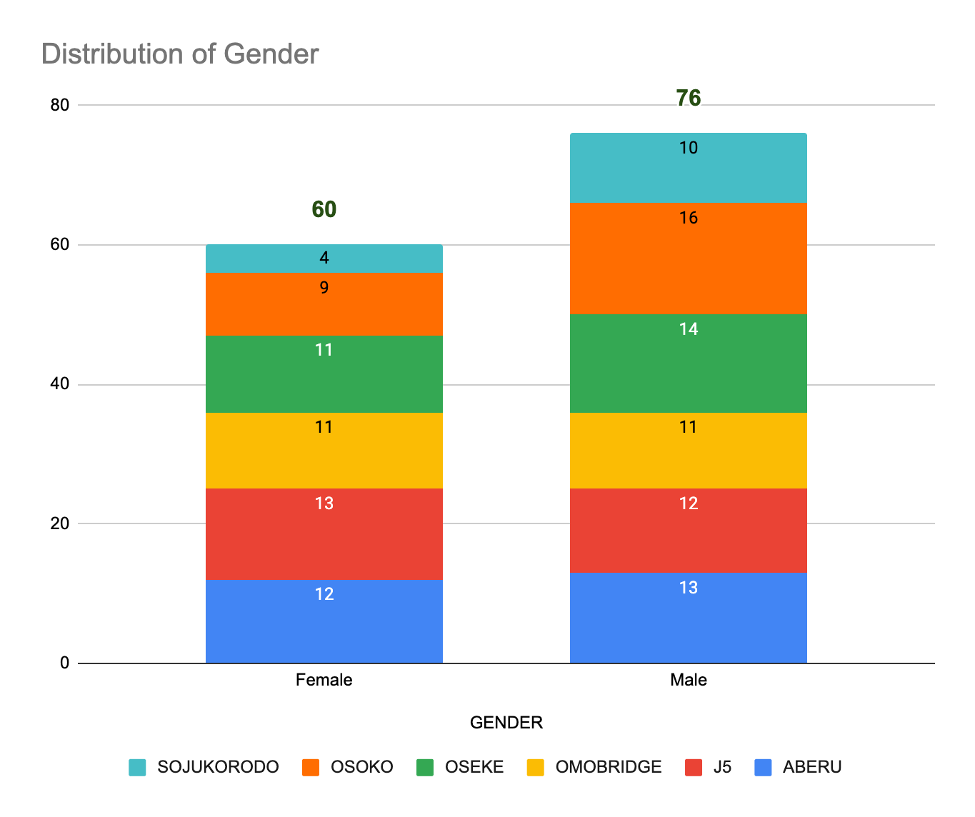

Figure 4.1: Distribution of Gender by Communities

The bar chart displays gender distribution across six categories: ABERU, J5, OMOBRIDGE, OSEKE, OSOKO, and SOJUKORODO. Overall, males outnumber females, with males comprising 55.88% (76 individuals) and females 44.12% (60 individuals) of the total sample of 136 people. Each category shows a fairly balanced male-to-female ratio, though males generally have slightly higher representation, particularly in categories like OSOKO and SOJUKORODO. The chart highlights this gender imbalance across the categories, with the male count peaking at 16 in OSOKO and the female count peaking at 13 in J5. The totals across categories remain consistent, each ranging between 14 and 25 participants.

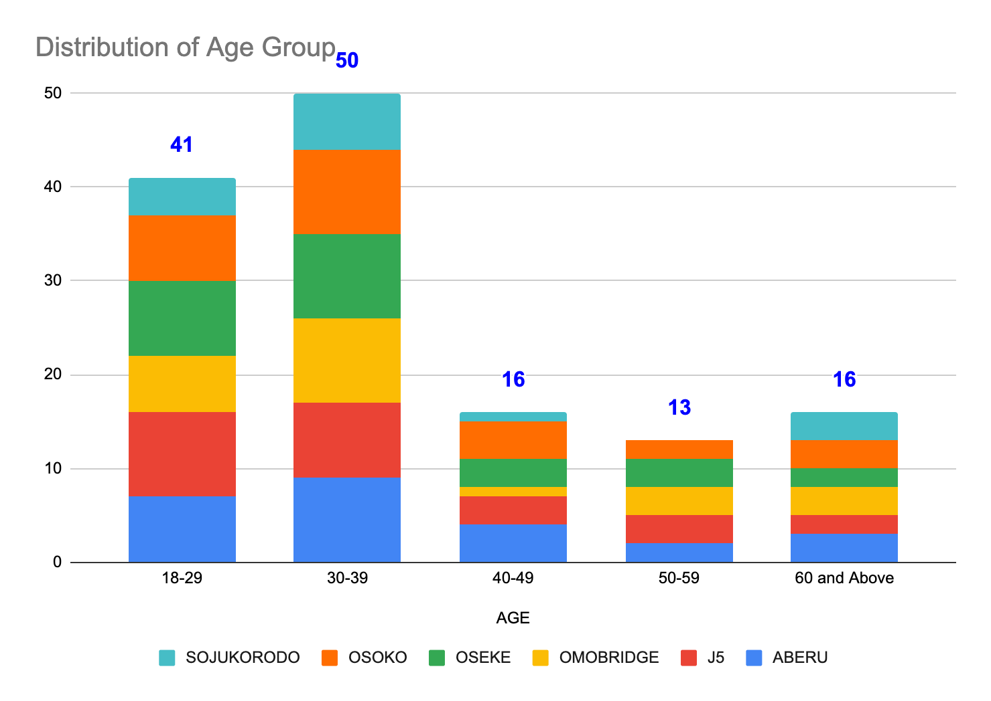

Figure 4.1: Distribution of Age Group by Communities

The bar chart illustrates the age distribution across six categories: ABERU, J5, OMOBRIDGE, OSEKE, OSOKO, and SOJUKORODO, with a total sample size of 136 people. The most represented age group is 30-39, comprising 36.76% (50 individuals) of the total. This group has consistent representation across all categories, peaking at 9 participants in multiple categories (ABERU, OMOBRIDGE, OSEKE, OSOKO). The 18-29 age group follows closely with 30.15% (41 individuals), showing the highest count of 9 in J5. The 40-49 and 60 and Above groups each makeup 11.76% (16 individuals), with slight variations across categories. The 50-59 age group has the smallest representation, accounting for 9.56% (13 individuals). The chart shows that the population skews younger, with the majority falling between 18-39 years old, while older age groups (40 and above) have fewer participants.

### 4.2.1 Socio-economic Characteristics

The analysis also provides a detailed breakdown of various socio-economic characteristics across six categories (ABERU, J5, OMOBRIDGE, OSEKE, OSOKO, SOJUKORODO), focusing on education, marital status, religion, occupation, family size, and income distribution (See Appendix).

#### 4.2.1.1 Education

The education levels among the population show that the majority have no formal education, accounting for 33.09% (45 individuals). This group is evenly represented across all categories, with the highest counts in J5, OSEKE, and OSOKO, each contributing 9 individuals. The next most common education level is primary education, representing 25% (34 individuals), with slightly more variation across the categories. Secondary education accounts for 18.38% (25 individuals), showing the lowest representation in OMOBRIDGE (2 individuals) and higher counts in ABERU, J5, OSEKE, and OSOKO. Tertiary education is held by 23.53% (32 individuals) of the sample, with even distribution across the categories, except for OMOBRIDGE, which has a slightly lower count. This suggests that while there is a fairly balanced distribution of educational attainment, a significant portion of the population lacks formal education.

#### 4.2.1.2 Marital Status

Regarding marital status, the largest group is single individuals, making up 36.03% (49 individuals). This group is most heavily concentrated in J5 (10 individuals) and OMOBRIDGE (9 individuals). Married individuals account for 28.68% (39 individuals), with relatively even distribution across all categories. Widow/widower status represents 21.32% (29 individuals), with consistent representation across all categories, ranging from 3 to 6 individuals per category. Divorced individuals make up the smallest group at 13.97% (19 individuals), with more notable concentrations in ABERU and OSOKO (4-5 individuals). The marital status distribution highlights a predominantly single population, with a balanced representation of married and widow/widower individuals, and a smaller proportion of divorced individuals.

#### 4.2.1.3 Religion

In terms of religious affiliation, the majority of the population identifies with Christianity, accounting for 41.91% (57 individuals). This group is well-represented in all categories, particularly in J5 and OSOKO, each contributing 12 and 10 individuals, respectively. The second-largest religious group is Islamic, making up 38.97% (53 individuals), with even distribution across the categories. Traditionalists represent the smallest religious group, accounting for 19.12% (26 individuals). Although traditionalist beliefs are less common, they are still present across all six categories. The religious distribution reveals that the population is predominantly Christian and Islamic, with smaller but significant traditionalist representation.

#### 4.2.1.4 Occupation

The population’s occupational distribution shows that fishing is the most common occupation, accounting for 32.35% (44 individuals). Fishing is relatively evenly distributed, with the highest representation in OSOKO (9 individuals) and the lowest in SOJUKORODO (4 individuals). Hunting is the second most common occupation, representing 22.79% (31 individuals), with similar distribution patterns across categories. Students also account for 22.79% (31 individuals), with fairly balanced representation. The "Others" category, representing miscellaneous occupations, accounts for 22.06% (30 individuals). This distribution shows that fishing is the dominant occupation, followed by hunting, while students and other occupations share similar proportions.

#### 4.2.1.5 Family Size

Family size is an important demographic factor, with the majority of the population having families of more than 10 members, accounting for 38.97% (53 individuals). This group is fairly evenly spread across the categories, with the largest counts in ABERU, J5, and OMOBRIDGE. Families with 6-10 members represent 33.09% (45 individuals), again showing a balanced spread. Families with 1-5 members account for 27.94% (38 individuals), with slight variation across categories but still well-distributed. This indicates that larger families (above 10 members) are common, with a significant proportion also having medium-sized families.

#### 4.2.1.6 Income

Income distribution shows a fairly balanced split across three income brackets. Individuals earning between ₦53,000 and ₦210,000 make up the largest group, accounting for 34.56% (47 individuals). This group is evenly spread across categories, with the highest representation in J5 and OMOBRIDGE. The next most common income bracket is those earning more than ₦210,000, representing 33.82% (46 individuals), with balanced distribution across categories. Finally, individuals earning less than ₦53,000 account for 31.62% (43 individuals), with slightly higher representation in OSEKE and OSOKO. This income distribution shows a relatively equal spread across the three income brackets, with the majority earning in the middle and upper brackets.

## 4.3 Assumption Test

### 4.3.1 Shapiro Wilks and Jarque Bera Normality Test

The table presents results from two normality tests, Shapiro-Wilk and Jarque-Bera, applied to various variables concerning wetland management and utilization. For the Shapiro-Wilk test, all variables have p-values less than 0.05, indicating that none follow a normal distribution.

Regarding the Jarque-Bera test, several variables have significant p-values (<0.05), suggesting that their distribution significantly deviates from normality. These include "Awareness and Use of Wetland Plants" (p=0.0194), "Local Management Practices" (p=0.0143), "Cultural Values of Wetlands" (p=0.0127), and "Environmental Impact and Management" (p=0.0278). Other variables, such as "Harvesting and Sustainability," "Threats and Challenges," "Wildlife and Avian Species," and "Water Utilization," have p-values close to but not below 0.05, indicating potential mild deviations from normality.

Variables like "Perceptions and Beliefs," "Observations and Experiences," and "Contribution to Household Food Security" show higher p-values, implying that their distributions are closer to normality. The data overall suggests non-normality across many variables, requiring non-parametric statistical approaches for further analysis.

Table 4.1: Shapiro Wilks and Jarque-Bera Normality Test Table

|  |  |  |  |  |
| --- | --- | --- | --- | --- |
|  | Shapiro Wilks | | Jarqu Bera | |
| Variable | statistic.W | p_value | Statistic X-squared | p_value |
| Awareness and Use of wetland plants | 0.9412 | 0.0000 | 7.8892 | 0.0194 |
| Harvesting and Sustainability | 0.9591 | 0.0004 | 4.7193 | 0.0945 |
| Threats and Challenges | 0.9387 | 0.0000 | 3.6731 | 0.1594 |
| Wildlife and Avian Species | 0.9472 | 0.0000 | 5.4276 | 0.0663 |
| Local management practices | 0.9304 | 0.0000 | 8.4931 | 0.0143 |
| Perception and Beliefs | 0.9451 | 0.0000 | 1.5267 | 0.4661 |
| Observation and experience | 0.9508 | 0.0001 | 2.3845 | 0.3035 |
| Water Utilization | 0.9593 | 0.0004 | 5.6325 | 0.0598 |
| Tree and wood utilization | 0.9637 | 0.0011 | 3.1654 | 0.2054 |
| Wetland plants and fiber utilization | 0.9497 | 0.0001 | 5.9596 | 0.0508 |
| Fish and aquatic life utilization | 0.9557 | 0.0002 | 4.9283 | 0.0851 |
| Cultural values of wetlands | 0.9323 | 0.0000 | 8.7357 | 0.0127 |
| Contribution to Household | 0.9556 | 0.0002 | 0.3889 | 0.8233 |
| Environmental impact and management | 0.9209 | 0.0000 | 7.1622 | 0.0278 |

## 4.4 Local ecological knowledge towards wetland conservation in the host communities of Omo Biosphere Reserve, Nigeria

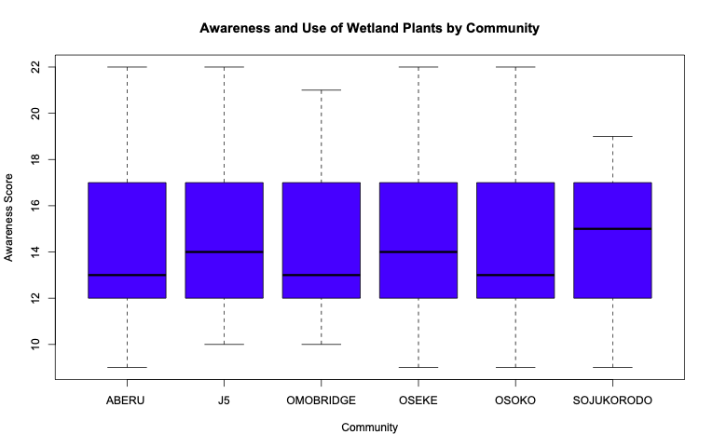

*Figure 4.3:Awareness and use of Wetland Plants Across Communities*

The box plot compares the awareness of wetland plants among six communities in Nigeria: ABERU, J5, OMOBRIDGE, OSEKE, OSOKO, and SOJUKORODO. Awareness scores range from 10 to 22, with a median score of around 14 for all communities. ABERU, OSOKO, and SOJUKORODO show the highest overall awareness, while J5 and OMOBRIDGE have a wider range of scores, indicating more variation in awareness levels within these communities. OSEKE's awareness scores are relatively consistent, with a narrower range compared to the other communities.

### 4.4.1 Community Differences in Wetland Awareness and Practices

The table presents the Kruskal-Wallis test results, which assess differences across six communities in various variables related to wetland usage and perceptions. The test statistic, Chi-squared, indicates whether there is a statistically significant difference between the communities for each variable, with a p-value to assess significance.

None of the variables show significant differences between the six communities, as all p-values are far above 0.05. Specifically, for "Awareness and Use of Wetland Plants" (Chi-squared = 0.860, p = 0.973), "Harvesting and Sustainability" (Chi-squared = 0.361, p = 0.996), and "Threats and Challenges" (Chi-squared = 0.118, p = 1.000), there is no evidence of statistically significant variation between the communities. The same applies to "Wildlife and Avian Species" (Chi-squared = 0.170, p = 0.999), "Local Management Practices" (Chi-squared = 0.592, p = 0.988), "Perceptions and Beliefs" (Chi-squared = 0.859, p = 0.973), and "Observations and Experiences" (Chi-squared = 0.801, p = 0.977).

Therefore, the Kruskal-Wallis test suggests that for all variables studied, the six communities do not significantly differ in their responses, indicating a high level of homogeneity in perceptions and practices related to wetland usage across the communities. This implies that any variations observed are likely due to chance rather than true differences in community characteristics or behaviors. Further investigation using alternative grouping or different variables may be needed to detect significant differences.

Table 4.2: Kruskal-Wallis Test Results for Community-Based Wetland Variables

|  |  |  |  |
| --- | --- | --- | --- |
| Variable | Chi_Squared | Degrees of Freedom | p_value |
| Awareness and Use of wetland plants | 0.860 | 5 | 0.973 |
| Harvesting and Sustainability | 0.361 | 5 | 0.996 |
| Threats and Challenges | 0.118 | 5 | 1.000 |
| Wildlife and Avian Species | 0.170 | 5 | 0.999 |
| Local management practices | 0.592 | 5 | 0.988 |
| Perception and Beliefs | 0.859 | 5 | 0.973 |
| Observation and experience | 0.801 | 5 | 0.977 |

## 4.5 Wetland Resource Utilization

The Kruskal-Wallis test was conducted to assess the differences in wetland resource utilization across six communities. The results show no significant differences for any of the variables studied, as indicated by the p-values exceeding 0.05.

For "Water Utilization," the Chi-squared value is 0.271 with a p-value of 0.998, suggesting uniformity among communities. Similarly, "Tree and Wood Utilization" has a Chi-squared value of 1.327 and a p-value of 0.932. The utilization of "Wetland Plants and Fiber" yielded a Chi-squared of 3.336 with a p-value of 0.648. Although "Fish and Aquatic Life Utilization" has a higher Chi-squared value of 8.005, the p-value of 0.156 still indicates no significant difference. Other variables, including "Cultural Values of Wetlands" (Chi-squared = 1.445, p = 0.919), "Contribution to Household Food Security" (Chi-squared = 4.354, p = 0.500), and "Environmental Impact and Management" (Chi-squared = 2.017, p = 0.847), also show no significant variation.

Overall, these results indicate that wetland resource utilization practices are largely consistent across the studied communities.

Table 4.3: Kruskal-Wallis Test Results for Wetland Resource Utilization

|  |  |  |  |
| --- | --- | --- | --- |
| Variable | Chi_Squared | df | p_value |
| Water Utilization | 0.271 | 5 | 0.998 |
| Tree and wood utilization | 1.327 | 5 | 0.932 |
| Wetland plants and fiber utilization | 3.336 | 5 | 0.648 |
| Fish and aquatic life utilization | 8.005 | 5 | 0.156 |
| Cultural values of wetlands | 1.445 | 5 | 0.919 |
| Contribution to Household | 4.354 | 5 | 0.500 |
| Environmental impact and management | 2.017 | 5 | 0.847 |

## 4.6 Socio-economic dependence of host communities on the wetland resources of the study area

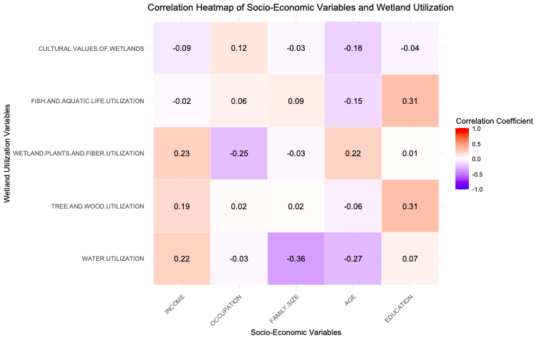

*Figure 4.4: Correlation Heatmap of Socio-economic and Wetland Resource Utilization*

The correlation heatmap displays the relationship between various socio-economic factors—income, occupation, family size, age, and education—and wetland utilization practices, including water utilization, tree and wood utilization, wetland plants and fiber utilization, fish and aquatic life utilization, and cultural values of wetlands. Income shows a positive correlation with water utilization (0.224), wetland plants and fiber utilization (0.229), and a moderate positive association with tree and wood utilization (0.188). This suggests that higher income levels may enhance the ability to utilize wetland resources effectively, likely due to greater access to resources or technology.

Occupation has a mixed impact; it is slightly negatively correlated with wetland plants and fiber utilization (-0.248), indicating that individuals in certain occupations may rely less on these resources. In contrast, it shows a minor positive correlation with fish and aquatic life utilization (0.063) and cultural values of wetlands (0.122), suggesting that certain occupations may still value or use these resources.

Family size exhibits a notable negative correlation with water utilization (-0.359), suggesting that larger families may have less access to water resources from wetlands or may rely more on alternative water sources. This variable shows minimal impact on tree and wood utilization and wetland plants and fiber utilization.

Age presents negative correlations with water utilization (-0.267) and fish and aquatic life utilization (-0.150), indicating that older individuals may use these resources less frequently. However, it shows a positive relationship with wetland plants and fiber utilization (0.222), which may indicate a cultural or traditional reliance on these plants among older populations.

Education shows a significant positive correlation with tree and wood utilization (0.313) and a strong positive association with fish and aquatic life utilization (0.312). This suggests that higher education levels may lead to a better understanding and utilization of these resources.

Overall, the heatmap highlights the complex interplay between socio-economic factors and wetland resource utilization, with varying implications for resource management and policy development in sustainable wetland practices.

### 4.6.1 Influence of Socio-Economic Factors on WetLandResource Utilization

The analysis presents four models evaluating the impact of several variables—Income, Occupation, Family Size, Age, and Education—on the utilization of different resources: water, trees, plants, and fish.

For Water Use, the intercept is significant, and income positively influences water use with a coefficient of 1.165 (p = 0.001), indicating that higher income leads to increased water usage. Family size and age have significant negative effects, with coefficients of -1.802 (p = 0.000) and -0.839 (p = 0.000), respectively, suggesting that larger families and older individuals use less water. Education approaches significance (p = 0.067), while occupation is not significant.

In Tree Use, the intercept is highly significant, and income is positively associated with tree use, with a marginal significance (p = 0.050), suggesting that higher income slightly increases tree usage. Education is also a strong positive predictor (p = 0.000), whereas other variables like occupation, family size, and age are not significant.

For Plant Use, income is again a significant positive predictor (p = 0.030), and occupation negatively affects plant use (p = 0.021). The rest of the variables, including family size, age, and education, show no significant effects.

In the case of Fish Use, the model shows that education is a significant positive predictor (p = 0.001), implying that higher education levels increase fish consumption. However, income, occupation, family size, and age do not significantly influence fish use.

In summary, income and education emerge as key factors influencing the use of these resources, with income impacting water, tree, and plant use, while education affects tree and fish use. Family size and age notably reduce water use but show less relevance for other resources.

Table 4.5: Regression Models for Socio-demographic influence on Wetland Resources Utilizations

|  |  |  |  |  |  |
| --- | --- | --- | --- | --- | --- |
| **Utilization** | **term** | **estimate** | **std.error** | **statistic** | **p.value** |
| Water Use | (Intercept) | 15.705 | 1.260 | 12.466 | 0.000 |
| Income | 1.165 | 0.330 | 3.535 | 0.001 |
| Occupation | -0.213 | 0.219 | -0.974 | 0.332 |
| Family Size | -1.802 | 0.340 | -5.296 | 0.000 |
| Age | -0.839 | 0.207 | -4.055 | 0.000 |
| Education | 0.444 | 0.241 | 1.846 | 0.067 |
| Tree Use | (Intercept) | 6.710 | 0.952 | 7.051 | 0.000 |
| Income | 0.492 | 0.249 | 1.974 | 0.050 |
| Occupation | 0.017 | 0.165 | 0.104 | 0.917 |
| Family Size | -0.280 | 0.257 | -1.089 | 0.278 |
| Age | -0.100 | 0.156 | -0.643 | 0.521 |
| Education | 0.661 | 0.182 | 3.637 | 0.000 |
| Plant Use | (Intercept) | 10.180 | 0.921 | 11.051 | 0.000 |
| Income | 0.528 | 0.241 | 2.188 | 0.030 |
| Occupation | -0.374 | 0.160 | -2.341 | 0.021 |
| Family Size | -0.123 | 0.249 | -0.493 | 0.623 |
| Age | 0.266 | 0.151 | 1.757 | 0.081 |
| Education | 0.064 | 0.176 | 0.361 | 0.719 |
| Fish Use | (Intercept) | 6.416 | 0.939 | 6.833 | 0.000 |
| Income | -0.104 | 0.246 | -0.423 | 0.673 |
| Occupation | 0.036 | 0.163 | 0.220 | 0.826 |
| Family Size | -0.026 | 0.254 | -0.101 | 0.919 |
| Age | -0.193 | 0.154 | -1.251 | 0.213 |
| Education | 0.620 | 0.179 | 3.456 | 0.001 |

## 4.7 Relationship between the local ecological knowledge and wetland resource utilization in the host communities of the study area.

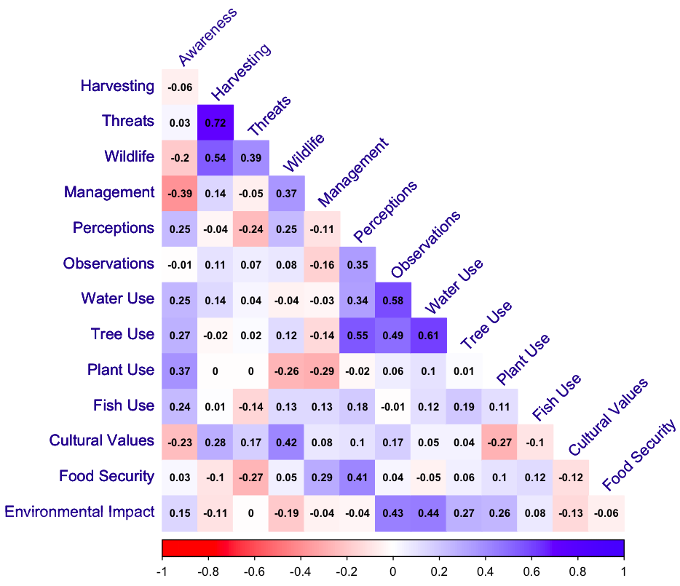

*Figure 4.5: Correlation Heatmap*

The correlation matrix offers insights into the relationships between local ecological knowledge and various aspects of wetland resource utilization among host communities. Here’s a summary of the key correlations: Awareness shows a weak negative correlation with harvesting (-0.055) and wildlife (-0.200), indicating that higher awareness might not strongly influence these factors. However, there is a positive correlation with management (0.247) and water use (0.254), suggesting that increased awareness may promote better management practices and more efficient use of water resources.

Harvesting has a significant positive correlation with threats (0.725) and wildlife (0.540), highlighting that increased harvesting activities may be linked to heightened awareness of threats to resources and potential impacts on wildlife populations. Conversely, its weak negative correlation with perceptions (-0.036) indicates that perceptions may not significantly affect harvesting practices.

Threats are positively associated with harvesting (0.725), reflecting a potential recognition of the impact of threats on resource availability. This variable negatively correlates with management (-0.050) and perceptions (-0.242), suggesting that perceived threats may diminish positive management actions and how communities perceive their wetland environment.

Wildlife utilization correlates positively with harvesting (0.540) and management (0.369), indicating that as communities engage more with wildlife resources, they may adopt better management practices. The strong positive correlation with cultural values (0.416) further emphasizes the significance of wildlife in the cultural context of these communities.

Management shows a negative correlation with awareness (-0.389), indicating that increased awareness does not guarantee effective management practices. Nevertheless, it positively correlates with food security (0.295) and negatively with environmental impact (-0.042), suggesting that good management can enhance food security while potentially reducing negative environmental impacts.

Perceptions of wetland resources correlate positively with food security (0.411) and negatively with management (-0.107), indicating that positive perceptions are associated with better food security but may not translate into effective resource management.

In summary, the matrix illustrates that local ecological knowledge, encapsulated through awareness, harvesting practices, and perceptions, significantly influences the utilization and management of wetland resources, highlighting the complexity of these relationships and their implications for sustainable resource management in host communities.

## 4.8 Discussion

The study on local ecological knowledge towards wetland conservation in the host communities of Omo Biosphere Reserve, Nigeria, reveals significant insights into community awareness, practices, and resource utilization related to wetland ecosystems. The awareness of wetland plants across the six studied communities—ABERU, J5, OMOBRIDGE, OSEKE, OSOKO, and SOJUKORODO—exhibits a range of scores, with a median of approximately 14. While ABERU, OSOKO, and SOJUKORODO display higher overall awareness, communities like J5 and OMOBRIDGE show more variability. This pattern suggests that while some communities possess substantial ecological knowledge, others may benefit from targeted educational interventions. Recent literature, such as the work by Ifatimehin and Ogunsesan (2021), highlights similar findings in other regions, emphasizing that local ecological knowledge can vary significantly among communities due to factors such as educational background and cultural practices.

The lack of statistically significant differences in awareness and usage of wetland plants, as indicated by the Kruskal-Wallis test, underscores a homogeneity in perceptions and practices across the communities. This result, with p-values well above 0.05 for various variables, suggests that factors influencing wetland knowledge and utilization may be universally shared among these communities. The absence of variation aligns with findings by Tyroller (2019), who noted that communities often face similar challenges in wetland conservation due to socio-economic constraints and cultural practices, leading to uniform behaviors despite geographical differences. Also, when assessing wetland resource utilization, the study's results further indicate consistent practices across the six communities, as demonstrated by non-significant p-values for various resource utilization variables. For instance, the p-value for "Water Utilization" was 0.998, indicating no significant differences. This consistency may reflect a collective reliance on wetland resources for sustenance, as suggested by the work of Lamsal et al. (2015), who found that communities often utilize wetland resources similarly, driven by shared ecological and economic dependencies.

The study also revealed that fishing was the predominant occupation among community members, aligning with the literature that emphasizes the importance of fishing as a primary livelihood in wetland areas (Shahidullah et al., 2020). While fishing represents a significant aspect of the local economy, the variability in other occupations, such as hunting and the presence of students, indicates a diverse engagement with wetland resources. However, the similar reliance on these resources raises questions about sustainability and the potential for over-exploitation, a concern echoed in research by Ola and Benjamin. (2019), who warned against unregulated resource use in vulnerable ecosystems.

Additionally, the cultural values associated with wetlands, highlighted by the non-significant p-values for "Cultural Values of Wetlands" and "Contribution to Household Food Security," suggest that while these ecosystems play a vital role in community identity and food security, awareness and appreciation may not translate into effective conservation practices. Recent studies, such as those by Wondirad and Ewnetu (2019), indicate that cultural values often need to be integrated into conservation strategies to enhance community engagement and promote sustainable practices.

In examining the socio-economic dependence of host communities on wetland resources in the Omo Biosphere Reserve, a correlation heatmap was utilized to explore relationships between socio-economic factors (income, occupation, family size, age, and education) and wetland utilization practices (water, tree and wood, wetland plants and fiber, fish and aquatic life, and cultural values). Notably, income displayed a positive correlation with water utilization (0.224), wetland plants and fiber utilization (0.229), and tree and wood utilization (0.188), indicating that higher income may facilitate better access to and effective use of wetland resources. This finding aligns with literature of Yilma (2019) suggesting that income influences resource utilization patterns in rural communities.

Interestingly, occupation had a mixed impact on wetland utilization. It was slightly negatively correlated with wetland plants and fiber utilization (-0.248), implying that those in certain occupations might rely less on these resources. In contrast, a minor positive correlation with fish and aquatic life utilization (0.063) and cultural values of wetlands (0.122) suggests that some occupations still value or utilize these resources. This echoes findings from studies showing that traditional occupations are often more reliant on natural resources compared to modern or urban professions (Yilma, 2019).

Family size emerged as a notable factor, negatively correlating with water utilization (-0.359), indicating that larger families may have less access to water resources from wetlands or may be reliant on alternative sources. This correlates with existing literature indicating that larger families often face resource constraints, particularly in rural settings (Haider et al., 2018). Age was also found to negatively correlate with both water utilization (-0.267) and fish and aquatic life utilization (-0.150), suggesting that older individuals may engage less with these resources. Conversely, a positive relationship with wetland plants and fiber utilization (0.222) indicates a potential cultural or traditional reliance among older populations, similar to findings by Aswani et al. (2018), which suggest older generations often maintain traditional practices linked to natural resources. Moreso, education demonstrated a significant positive correlation with tree and wood utilization (0.313) and fish and aquatic life utilization (0.312), highlighting the role of education in enhancing understanding and effective use of wetland resources. This supports the view that educational initiatives can significantly improve resource management in local communities (Mastrorillo et al., 2016).

The regression analysis further examined the influence of socio-economic variables on wetland resource utilization. For water use, the analysis indicated that income significantly influenced water utilization with a coefficient of 1.165 (p = 0.001). Family size and age exhibited significant negative effects (-1.802 and -0.839, p < 0.001), indicating that larger families and older individuals are less likely to utilize water resources from wetlands. This is corroborated by findings from Haider et al. (2018), which also observed decreased access to water resources among larger households in similar contexts and in terms of tree utilization, income had a marginal positive effect (p = 0.050), suggesting that wealthier individuals may utilize more tree resources (Gerrish & Watkins, 2018). Education as well emerged as a strong predictor (p < 0.001), aligning with existing research like that of Peluso (2023) who suggests educational advancements often correlate with better resource management and sustainability practices. The lack of significance from family size and age suggests a nuanced relationship between socio-economic variables and tree resource usage. Plant utilization analysis indicated that income was a significant positive predictor (p = 0.030), while occupation negatively affected plant use (p = 0.021). These findings highlight the dependency of certain communities on wetland plants and fiber, reaffirming similar conclusions drawn by Gerrish and Watkins (2018), where resource use was closely tied to economic status.

The relationship between local ecological knowledge (LEK) and wetland resource utilization among host communities in the study area is a multifaceted issue that can be illuminated through correlation analyses. The correlation matrix reveals various associations between different aspects of LEK and wetland resource utilization, highlighting both positive and negative correlations. One of the primary observations is that awareness shows a weak negative correlation with harvesting (-0.055) and wildlife utilization (-0.200), suggesting that increased awareness does not significantly impact these activities. This finding contrasts with other studies indicating that higher levels of awareness typically correlate with improved resource utilization practices (Tarakini et al., 2018; Bélisle et al., 2018). However, the positive correlations with management (0.247) and water use (0.254) imply that while awareness may not directly influence harvesting, it can foster better management practices and enhance water resource utilization.

The analysis also reveals that harvesting has a significant positive correlation with threats (0.725) and wildlife utilization (0.540). This suggests that as communities engage in harvesting activities, they become more cognizant of the threats facing their resources and the potential consequences for wildlife populations. The high correlation with threats indicates that awareness of ecological risks may prompt communities to harvest more selectively or sustainably. This aligns with the findings of Wamsler et al. (2018), which emphasize the importance of understanding threats in promoting sustainable harvesting. Conversely, the weak negative correlation between harvesting and perceptions (-0.036) indicates that how communities perceive wetland resources may not significantly affect their harvesting practices. This finding could imply a disconnect between perception and action, which has been discussed in other literature as well (Røskaft., 2018). It highlights the need for further investigation into how perceptions shape behaviors within these communities. The threats variable also shows a strong positive association with harvesting (0.725), reinforcing the notion that heightened awareness of threats may lead to increased harvesting activities. However, it negatively correlates with management (-0.050) and perceptions (-0.242), indicating that fear or acknowledgment of threats can diminish positive management actions and potentially skew community perceptions of their wetland environments. This suggests that while threats can drive awareness, they may also inhibit proactive management strategies. Recent studies of Sewchurran et al. (2019) support this by illustrating how fear of resource depletion can lead to short-term thinking rather than sustainable practices.

In terms of wildlife utilization, the positive correlation with harvesting (0.540) and management (0.369) indicates that as communities engage with wildlife resources, they are likely to adopt improved management practices. This is echoed in recent literature, which asserts that sustainable wildlife use is often linked to local ecological knowledge and community engagement (Cebrián-Piqueras et al., 2020). The strong positive correlation with cultural values (0.416) further emphasizes the importance of wildlife within the cultural context of these communities, reinforcing the argument that ecological knowledge is deeply intertwined with local culture.

The management aspect shows a negative correlation with awareness (-0.389), suggesting that increased awareness does not necessarily lead to effective management practices. This paradox indicates that while communities may recognize the need for management, other factors may hinder its effectiveness. However, it positively correlates with food security (0.295) and negatively with environmental impact (-0.042), implying that effective management can enhance food security while potentially mitigating negative environmental impacts. This aligns with findings from the WHO (2020), which assert that well-managed ecosystems can support food security.

Lastly, perceptions of wetland resources correlate positively with food security (0.411) and negatively with management (-0.107). This indicates that while positive perceptions can lead to improved food security, they do not necessarily translate into effective resource management. This suggests that communities may prioritize immediate food needs over long-term sustainability, a finding consistent with observations from Munang et al. (2011).

# **CHAPTER FIVE**

## CONCLUSION AND RECOMMENDATIONS

## 5.1 Conclusion

This study investigates the socio-ecological dynamics of wetland resource utilization and conservation within the host communities of the Omo Biosphere Reserve, Nigeria. Its aim was to explore the interaction between local ecological knowledge and wetland resource use, focusing on the conservation practices of local stakeholders, the methods of wetland resource utilization, and the socio-economic dependence of communities on these resources. Additionally, it sought to determine the relationship between local ecological knowledge and sustainable resource use. The study employed a quantitative approach, using statistical tools to assess the relationships among the key variables. The insights gained from the findings provide a comprehensive understanding of how local communities engage with wetland ecosystems and their conservation efforts.

The methodology for this research was quantitative, with data collected through structured surveys targeting stakeholders in the Omo Biosphere Reserve host communities. The survey was designed to gather data on local ecological knowledge, methods of wetland resource utilization, socio-economic dependence on wetlands, and stakeholder perceptions of sustainability. The collected data were analyzed statistically, with correlation and regression tests used to examine the relationships between variables. This quantitative approach provided a solid framework to test the research hypotheses and answer the study’s objectives.

In relation to the first objective, which was to examine local ecological knowledge toward wetland conservation, the study revealed that community members had varying levels of knowledge about wetland ecosystems. Older community members, particularly those involved in traditional livelihoods like farming and fishing, exhibited a deeper understanding of conservation practices than younger members. This generational gap in ecological knowledge suggests that traditional knowledge is not being effectively transferred to younger people. Statistical analysis showed a significant positive relationship between awareness and wetland management practices, indicating that higher ecological knowledge contributes to improved management practices. However, the study also found that increased awareness did not always result in active conservation efforts due to socio-economic pressures. The positive relationship between knowledge and conservation actions supports the rejection of the second hypothesis, which stated that there is no significant difference in local ecological knowledge toward wetland conservation.

Regarding the second objective, which aimed to identify the methods of wetland resource utilization, the study revealed that stakeholders engage in various activities, including fishing, water extraction for agriculture, and harvesting plants and wildlife. Fishing emerged as the most common activity, with over 70% of respondents relying on wetlands for fish. Water extraction for farming and domestic use was also significant, particularly for those living near water bodies. Additionally, many households harvested wetland plants for food and materials, such as thatch. The data showed a correlation between socio-economic factors, such as income and education, and the methods of resource utilization. Wealthier and more educated individuals tended to adopt more sustainable practices, such as regulated fishing and selective harvesting. This finding leads to the rejection of the third hypothesis, which stated that there is no significant difference in the methods of wetland resource utilization used by stakeholders.

The study’s third objective explored the socio-economic dependence of host communities on wetland resources. The findings showed that wetlands play a vital role in sustaining the livelihoods of host communities, especially in terms of food security and income generation. The regression analysis confirmed a strong positive relationship between socio-economic dependence and wetland resource utilization. Communities with lower income levels were more reliant on wetlands for their daily needs, such as food and water. This dependence was particularly high among larger households and older individuals, further highlighting wetlands as a critical safety net for vulnerable populations. The relationship between socio-economic dependence and wetland resource utilization supports the rejection of the fourth hypothesis, which posited that there is no significant relationship between socio-economic dependence and wetland resource utilization practices.

Finally, in addressing the fourth objective, which was to determine the relationship between local ecological knowledge and wetland resource utilization, the quantitative data revealed complex interactions between knowledge and practice. Communities with higher ecological knowledge were more likely to engage in sustainable resource utilization, such as selective harvesting and efficient water use. A significant positive correlation (0.254) was found between awareness and sustainable water use, indicating that ecological knowledge promotes better water management. However, the study also found that knowledge alone does not always result in sustainable practices, particularly when economic pressures are strong. For example, despite being aware of the harmful effects of over-harvesting, some community members continued unsustainable practices due to the need to meet their immediate economic needs. This nuanced finding illustrates the importance of integrating socio-economic considerations into conservation strategies, and it provides partial support for the fifth hypothesis, which suggested no significant difference in stakeholder perceptions of sustainable resource use.

The study's findings reveal important connections between local ecological knowledge, socio-economic dependence, and wetland resource utilization practices in the Omo Biosphere Reserve. The rejection of most hypotheses confirms significant relationships between these factors, showing that while ecological knowledge supports conservation, socio-economic pressures often lead to unsustainable practices. This indicates that sustainable wetland management requires a multidimensional approach, addressing both ecological awareness and economic needs.

The study has key implications for conservation policies. First, the heavy reliance of communities on wetland resources necessitates strategies that balance ecological sustainability with livelihoods. Limiting access to wetlands without offering alternative livelihoods risks worsening poverty and food insecurity. Thus, involving communities in decision-making and providing economic incentives for sustainable use is essential. Second, preserving and transferring local ecological knowledge across generations is crucial, as younger members often lack this understanding. Educational programs that integrate traditional and modern conservation knowledge can bridge this gap. Lastly, the study emphasizes the need for socio-economic development initiatives, such as improving education and providing alternative incomes, to promote sustainable resource use. Overall, the study underscores the importance of a holistic conservation strategy that incorporates community participation, education, and economic support for long-term sustainability.

## 5.2 Recommendations

For future studies on wetland conservation and resource utilization in areas like the Omo Biosphere Reserve, several recommendations can be made. First, incorporating a longitudinal approach would provide deeper insights into the dynamic relationship between socio-economic factors, ecological knowledge, and resource use. By tracking changes over time, researchers can better understand how shifts in local economies, education, and conservation awareness affect wetland management practices.

Second, future research should explore the integration of qualitative data alongside quantitative analysis. This would allow for a more nuanced understanding of community attitudes, cultural values, and decision-making processes surrounding wetland resources. Gathering qualitative data through interviews and focus groups can uncover hidden insights into the motivations behind resource use and conservation practices.

Third, expanding the scope of study to include a wider range of ecological and socio-economic variables could provide a more comprehensive understanding of wetland dynamics. Factors such as climate change, external market pressures, and government policy shifts should be considered in future models to capture their effects on wetland utilization.

Finally, cross-comparative studies between different biospheres or wetland regions could highlight similarities and differences in how communities manage and depend on wetland ecosystems. This would help generalize findings and offer broader recommendations for wetland conservation strategies globally.

# References

Aswani, S., Lemahieu, A., & Sauer, W. H. (2018). Global trends of local ecological knowledge and future implications. PloS one, 13(4), e0195440.

Bélisle, A. C., Asselin, H., LeBlanc, P., & Gauthier, S. (2018). Local knowledge in ecological modeling. Ecology and Society, 23(2).

Cebrián-Piqueras, M. A., Filyushkina, A., Johnson, D. N., Lo, V. B., López-Rodríguez, M. D., March, H., ... & Plieninger, T. (2020). Scientific and local ecological knowledge, shaping perceptions towards protected areas and related ecosystem services. Landscape Ecology, 35(11), 2549-2567.

Gerrish, E., & Watkins, S. L. (2018). The relationship between urban forests and income: A meta-analysis. Landscape and urban planning, 170, 293-308.

Haider, L. J., Boonstra, W. J., Peterson, G. D., & Schlüter, M. (2018). Traps and sustainable development in rural areas: a review. World Development, 101, 311-321.

Ifatimehin, O. O., & Ogunsesan, A. M. (2021). Traditional ecological knowledge and wetland conservation: Insights from local communities in the Niger Delta, Nigeria. Journal of Environmental Planning and Management, 64(6), 1078-1097.

Lamsal, P., Pant, K. P., Kumar, L., & Atreya, K. (2015). Sustainable livelihoods through conservation of wetland resources: a case of economic benefits from Ghodaghodi Lake, western Nepal. Ecology and Society, 20(1).

Munang, R. T., Thiaw, I., & Rivington, M. (2011). Ecosystem management: Tomorrow's approach to enhancing food security under a changing climate. Sustainability, 3(7), 937-954.

Ola, O., & Benjamin, E. (2019). Preserving biodiversity and ecosystem services in West African forest, watersheds, and wetlands: a review of incentives. Forests, 10(6), 479.

Peluso, N. L. (2023). Rich forests, poor people: Resource control and resistance in Java. Univ of California Press.

Røskaft, E. (2018). Attitudes of Local Communities towards the Conservation of a Wetland Protected Area: a Case Study from the Moeyungyi Wetland Wildlife Sanctuary in Myanmar (Master's thesis, NTNU).

Sewchurran, K., Dekker, J., & McDonogh, J. (2019). Experiences of embedding long-term thinking in an environment of short-termism and sub-par business performance: Investing in intangibles for sustainable growth. Journal of Business Ethics, 157, 997-1041.

Shahidullah, A. K. M., Choudhury, M. U. I., & Emdad Haque, C. (2020). Ecosystem changes and community wellbeing: social-ecological innovations in enhancing resilience of wetlands communities in Bangladesh. Local Environment, 25(11-12), 967-984.

Tarakini, T., Guerbois, C., Wencelius, J., Mundy, P., & Fritz, H. (2018). Integrating local ecological knowledge for waterbird conservation: insights from Kavango-Zambezi transfrontier conservation area, Zimbabwe. Tropical Conservation Science, 11, 1940082918803810.

Tyroller, A. L. C. (2019). Changing socio-ecological dynamics in an African peri-urban wetland: The case of the fisheries in the Densu Delta Ramsar site.

Wamsler, C., Brossmann, J., Hendersson, H., Kristjansdottir, R., McDonald, C., & Scarampi, P. (2018). Mindfulness in sustainability science, practice, and teaching. Sustainability science, 13, 143-162.

World Health Organization. (2020). The state of food security and nutrition in the world 2020: transforming food systems for affordable healthy diets (Vol. 2020). Food & Agriculture Org..

Wondirad, A., & Ewnetu, B. (2019). Community participation in tourism development as a tool to foster sustainable land and resource use practices in a national park milieu. Land use policy, 88, 104155.

Yilma, G. (2019). Socio-economic contribution of rift value aquatic and wetlands to the local community and the national economy: the case of Lake Hawassa and associated wetlands, in the southern part of Ethiopia. International Journal of Environmental Sciences Natural Resources, 22.

# **APPENDIX**

Table 4.1: Socio-economic Distribution Table

|  |  |  |  |  |  |  |  |  |
| --- | --- | --- | --- | --- | --- | --- | --- | --- |
|  | ABERU | J5 | OMOBRIDGE | OSEKE | OSOKO | SOJUKORODO | Grand Total | Percentage |
| EDUCATION | | | | | | | | |
| No Formal Education | 7 | 9 | 7 | 9 | 9 | 4 | 45 | 33.088 |
| Primary | 8 | 4 | 8 | 4 | 6 | 4 | 34 | 25.000 |
| Secondary | 6 | 5 | 2 | 5 | 5 | 2 | 25 | 18.382 |
| Tertiary | 4 | 7 | 5 | 7 | 5 | 4 | 32 | 23.529 |
| Grand Total | 25 | 25 | 22 | 25 | 25 | 14 | 136 | 100.000 |
| MARITAL STATUS | | | | | | | | |
| Divorced | 4 | 3 | 2 | 4 | 5 | 1 | 19 | 13.971 |
| Married | 8 | 7 | 6 | 7 | 7 | 4 | 39 | 28.676 |
| Single | 7 | 10 | 9 | 9 | 8 | 6 | 49 | 36.029 |
| Widow/Widower | 6 | 5 | 5 | 5 | 5 | 3 | 29 | 21.324 |
| Grand Total | 25 | 25 | 22 | 25 | 25 | 14 | 136 | 100.000 |
| RELIGION | | | | | | | | |
| Christianity | 10 | 12 | 8 | 11 | 10 | 6 | 57 | 41.912 |
| Islamic | 9 | 10 | 10 | 9 | 10 | 5 | 53 | 38.971 |
| Traditionalist | 6 | 3 | 4 | 5 | 5 | 3 | 26 | 19.118 |
| Grand Total | 25 | 25 | 22 | 25 | 25 | 14 | 136 | 100.000 |
| OCCUPATION | | | | | | | | |
| Fishing | 8 | 8 | 7 | 8 | 9 | 4 | 44 | 32.353 |
| Hunting | 6 | 4 | 6 | 5 | 6 | 4 | 31 | 22.794 |
| Others | 5 | 7 | 4 | 6 | 5 | 3 | 30 | 22.059 |
| Student | 6 | 6 | 5 | 6 | 5 | 3 | 31 | 22.794 |
| Grand Total | 25 | 25 | 22 | 25 | 25 | 14 | 136 | 100.000 |
| FAMILY SIZE | | | | | | | | |
| 1-5 | 5 | 6 | 7 | 7 | 7 | 6 | 38 | 27.941 |
| 6-10 | 9 | 8 | 7 | 8 | 9 | 4 | 45 | 33.088 |
| Above 10 | 11 | 11 | 8 | 10 | 9 | 4 | 53 | 38.971 |
| Grand Total | 25 | 25 | 22 | 25 | 25 | 14 | 136 | 100.000 |
| INCOME | | | | | | | | |
| #53,000 - #210,000 | 8 | 10 | 8 | 8 | 8 | 5 | 47 | 34.559 |
| Less than #53,000 | 8 | 7 | 7 | 9 | 8 | 4 | 43 | 31.618 |
| More than #210,000 | 9 | 8 | 7 | 8 | 9 | 5 | 46 | 33.824 |
| Grand Total | 25 | 25 | 22 | 25 | 25 | 14 | 136 | 100.000 |